Professional Mixer
FM-4ME/FM-6ME/FM-8ME

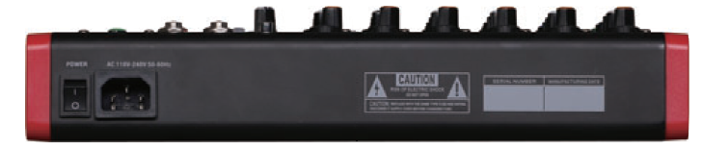
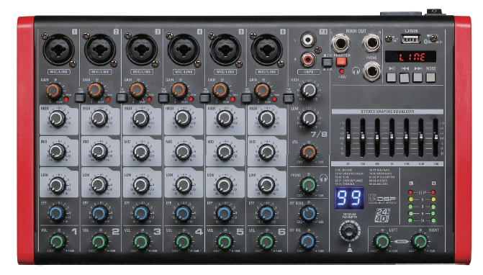

Features:

• 2 /4/ 6 combi connector support XLR and MIC inputs
• 1 stereo input.
• MIC input has attenuation function
• 3 segments EQ adjustments on each channel
• 7 Bands EO can be adjustable on main output
• 48V Phantom power supply
• 99 kinds of DSP effect
• MP3 player with blue tooth and record function

Specification:

Model | FM-4ME | FM-6ME | FM-8ME
Signal Noise Ratio | >90d8
Total Harmonic Distortion | 0.05%
Frequency response | 20HZ-20kHZ (+3dB)
Max output level | OdBu
Auxiliary max output level | 17d8u(1 kw,THD=0.5% )
Earphone Max output level | 17d8u/150Q ( +25d8m )
Power Supply | 100-240V 6A 250V


Page 1 of 1 www.ftdaudio.com, info@ftdaudio.com

